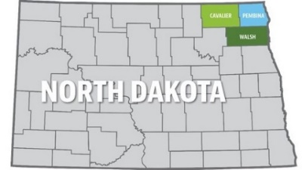**Northern Valley**

**Human Services Zone**

**(formerly known as Cavalier, Pembina & Walsh County Social Services)**

**Cavalier County Location Pembina County Location Walsh County Location**

**324 7th Avenue 300 Boundary Road W 516 Cooper Avenue**

**Langdon, ND 58249 Cavalier, ND 58220 Grafton, ND 58237**

**701-256-2175 701-265-8441 701-352-5111**

**FAX 701-256-2179 FAX 701-265-8058 FAX 701-352-5060**

**Zone Board Agenda**

**August 09, 2022**

**NVHSZ office**

**Lila Mielke Room**

**Basement of Chase Building in Grafton**

**Call the meeting to order:**

**Approval of July 2022 minutes:**

**Approval of Bills:**

**Review of expenses: Direct and Indirect**

**Indirect Payment:**

**Vehicle update:**

**Program Updates:**

**CPS**

**FC/In Home**

**Eligibility**

**DCA**

**CHINS**

**Assistance provided to Mountain Lakes**

**Children in our custody:**

* **Apartment**
* **Detention**

**Caseload statistics:**

**Next Board meeting September 13, 2022 Pembina County Office**

**ADJOURN**