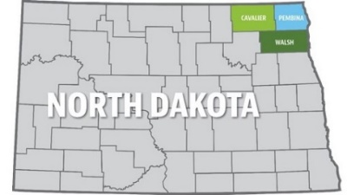**Northern Valley**

**Human Services Zone**

**(formerly known as Cavalier, Pembina & Walsh County Social Services)**

**Cavalier County Location Pembina County Location Walsh County Location**

**324 7th Avenue 300 Boundary Road W 516 Cooper Avenue**

**Langdon, ND 58249 Cavalier, ND 58220 Grafton, ND 58237**

**701-256-2175 701-265-8441 701-352-5111**

**FAX 701-256-2179 FAX 701-265-8058 FAX 701-352-5060**

**Zone Board Agenda**

**April 12, 2021**

**NVHSZ office**

**Cavalier Site (Pembina County)**

**Teams Meeting online**

**Call the meeting to order:**

**Approval of March 2021 minutes:**

**Approval of Bills:**

**CPS Centralized Intake update:**

**Office updates related to Covid:**

**Staff continuing to work from home**

**Phone update:**

**On call for SW staff:**

**Zone Vehicles:**

**Legislative Updates:**

**Next Board meeting May 10, 2021 9 am Walsh County Office**

**ADJOURN**